**Ann Arbor Public Schools Paycheck Inquiry Instructions**

*Instructions for accessing paycheck inquiry on new employee HR portal*

1. Navigate to: <https://nweweb.wash.k12.mi.us/eSuite_AnnArbor/Websites.HR.Portal/Default.aspx>

(You may want to save this as a favorite on your personal computer/device)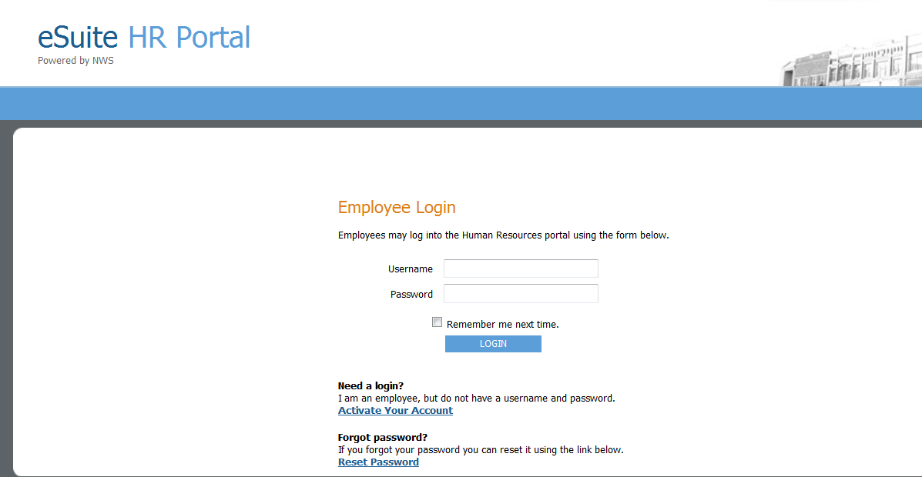

1. Click on the link ‘Activate Your Account’



1. Enter your last name and social security number (twice) and click ‘Continue’.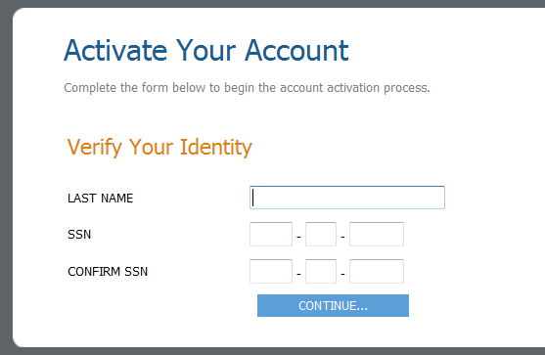
2. Create a username and password following the requirements indicated on the screen

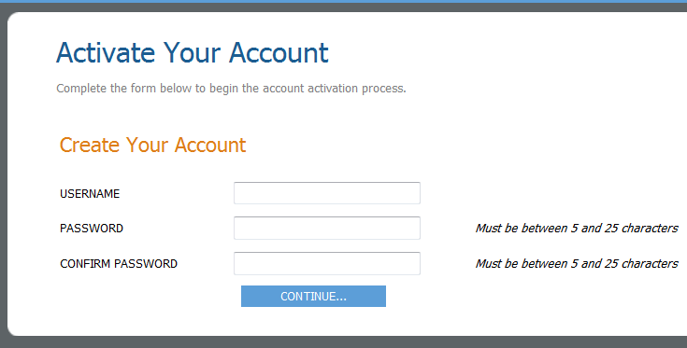

1. Your account should now be activated. Click on ‘Click to Login’ to navigate back to the login screen.

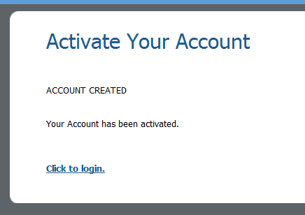

1. Log in using your newly created username and password.

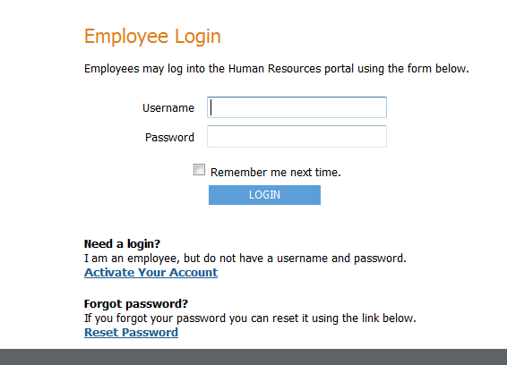

1. To view your paycheck, use the ‘MY HR’ menu at the top of the page and click on the ‘Paychecks’ option.

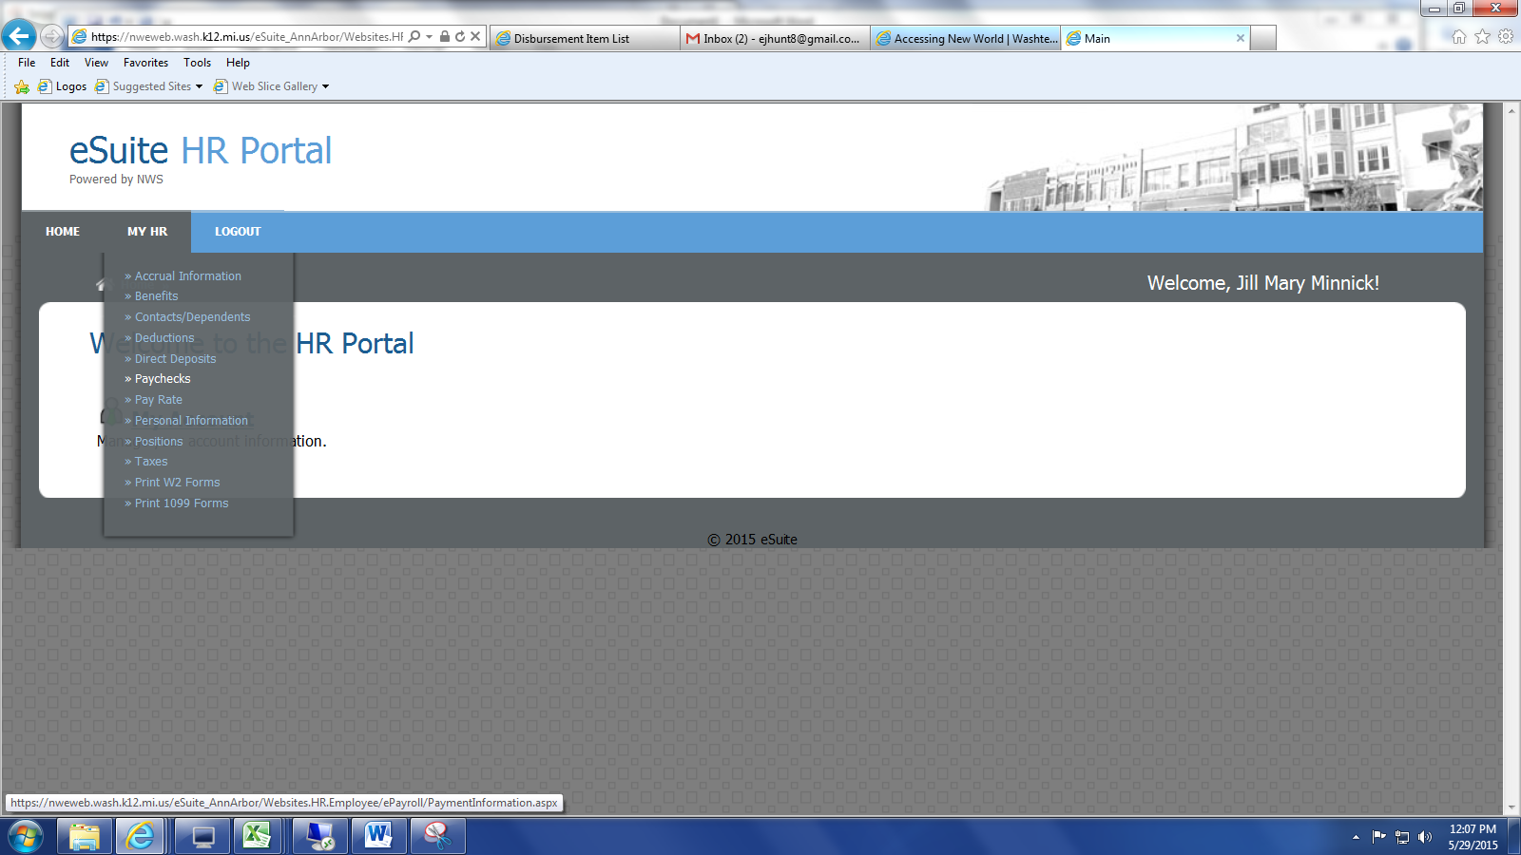

1. From the ‘Select a Pay Period’ drop-down menu, the first period in the list is the most recent paycheck. The date range represents the two week period associated with that pay date. (For example, the 5/29/2015 pay date will display a pay period of 5/3/2015 – 5/16/2015)

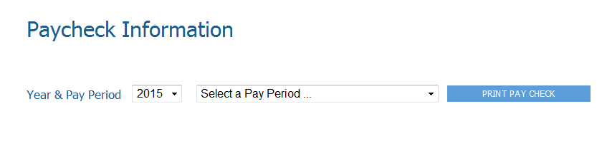

1. Once you select a pay period, a paycheck inquiry will appear on screen. To obtain a printable PDF paystub, click on the ‘PRINT PAY CHECK’ button located immediately to the right of the drop-down.